

**Assignment # 2**

**Web Application Development**

**Total Marks: 100**  **Date:** ________________

**Submission Date: _________________**

**Name__________________________ Roll No. _______________________ Class: ___________**

**Instructions:**

**I. Read the question carefully and provide the answer according to that.**

**II. You should create your own solution according to your logic. Any similarity with other student and internet will be consider as cheating and your assignment will be marked as ZERO.**

Write HTML/CSS of the following Pages. You can use any set of images but layout should be same.

Make it responsive while using your custom CSS(use media queries).

Make responsive for three screens only

Screen 1: 1024 to 1920

Screen 2: 768 to 1023

Screen 3: 450 to 767

Note: Use All Custom CSS and use external CSS only.

**Layout 1:**

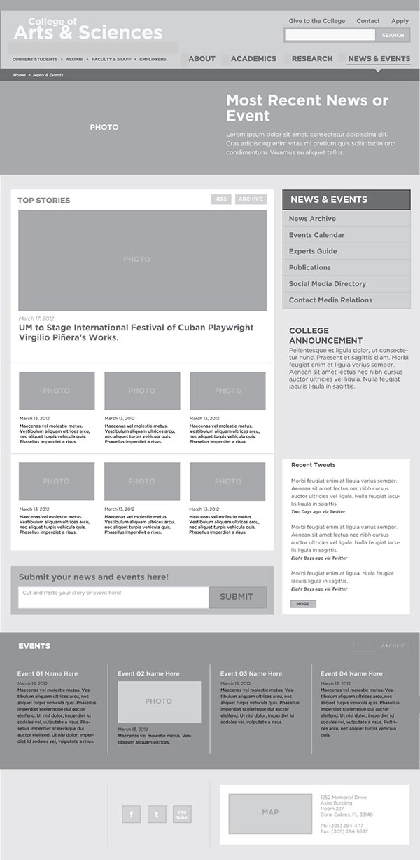

**Layout 2:**

